NPFC-2024-TWG CMSA08-WP14

Maturity at age of chub mackerel Scomber japonicus caught in the northwestern Pacific Ocean by China and Japan

Akihiro MANABE*, Ryuji YUKAMI*, Momoko ICHINOKAWA*, Heng ZHANG **
*Japan Fisheries and Education Agency (FRA), Japan
**East China Sea Fisheries Research Institute, Chinese Academy of Fishery Science, China

Summary
Maturity rate at age of chub mackerel is examined by China and Japan. Quarterly maturity at age data is submitted from China and Yearly maturity at age data is submitted from Japan. Yearly maturity at age data from China is estimated using arithmetic mean of quarterly data. Chinese maturity at age data shows early maturation from 2018-2022 and Japanese maturity at age data shows late maturation at the concurrent years, however, also shows early maturation when the stock was scarce. The maturity at age data for the stock assessment requires discussion however it is recommended to use proxy values rather than highly variable number that changes on annual basis.

Maturity at age
Maturity rate is a ratio of matured individuals within observed samples and is age specific. Based on the assumption that the sample is correctly obtained from the population, maturity rate is applied to stock biomass of corresponding age to estimate spawning stock biomass.
For chub mackerels in the northwestern Pacific, spawning grounds of chub mackerels are widely distributed along the coast of Japan with central spawning ground located at waters around Izu Islands (Watanabe and Yatsu 2006, Kanamori et al. 2019) and other spawning grounds located along the Pacific coast of Japan from Kagoshima prefecture (Watanabe 2010) to Tohoku region (Yukami et al. 2023). The spawning season begins from January till June with the main season in March and April according to the distribution and egg abundance (Yukami et al. 2023). Maturity at age data is available from two members: China and Japan. Chinese age is adjusted to set the date of age incrementation as July 1st and yearly maturity at age is calculated based on fishing year (Q3 to Q2 of the following year).

China
Chinese data consist of quarterly maturity at age data from calendar year of 2018 to 2022, which is converted into 2017-2022 fishing year. In China, the criterion of determination is based on empirical observation of the gonad of chub mackerel, which is sampled at random from the catch. The quarterly maturity at age data is shown in Table 1 and Figure 1. Maturity level shows seasonal fluctuation as it increases towards Q1 an decreases towards Q3, representing the development of gonad for spawning season and post-spawning, respectively. Maturity of age-0 is 0 for all data except for 1st quarter of 2018. Maturity of age-1 is less than 0.5, for most of quarters, maturity of age-2 fluctuates between 0.25 to 0.92, and maturity of age-3 is above 0.7. Maturity rate of age-4 and above are all considered as 100%.
To compare the maturity rate with Japan, annual maturity at age needs to be estimated. Since the original submitted maturity at age data from China uses arithmetic mean to calculate the annual data, the same method is applied to the fishing year-based maturity data. Table 2 and Figure 2 show the annual maturity at age from China. Annual maturity at age shows almost all age-0 fish is immature and maturity of age-1 is low (< 18%) while age-2 is partially matured (48%~56%) and age-3 is mostly matured (> 88%). All fish of age-4+ are matured throughout the years. For 2017 fishing year, the maturity rate exhibits higher rate compared to the other fishing year. This is due to the availability of the data is skewed to the spawning season (2018/Q1-Q2), which may increase the maturity due to the development of gonad whereas other years include post-spawning season into the arithmetic mean.
To estimate the maturity at age during the spawning season, arithmetic mean of Q1 and Q2 is used to estimate the maturity at age data. Table 2 and Figure 2 also show the seasonal maturity at age. The pattern exhibits similar pattern as the annual mean, however, seasonal mean is higher due to the gonadal development in Q1 and Q2.

Table 1. Quarterly maturity at age from China with adjusted age.

Table 2. Yearly maturity at age from China with adjusted age for annual mean and seasonal mean. Annual mean represents arithmetic mean of Q3-Q2 of the following year and seasonal mean represents arithmetic mean of Q1 and Q2.

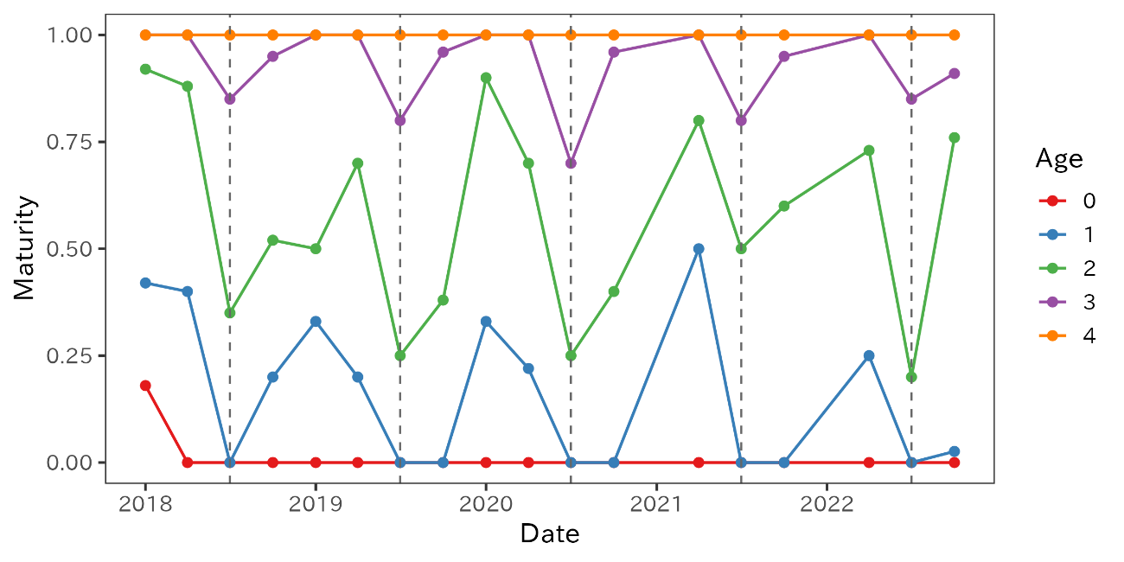
Fig 1. Quarterly maturity rate at age from Chinese catch. The maturity rates of age-4 represent age-4+ since all fish above age-4 are 100% matured. Dotted vertical lines represent the beginning of the fishing year.

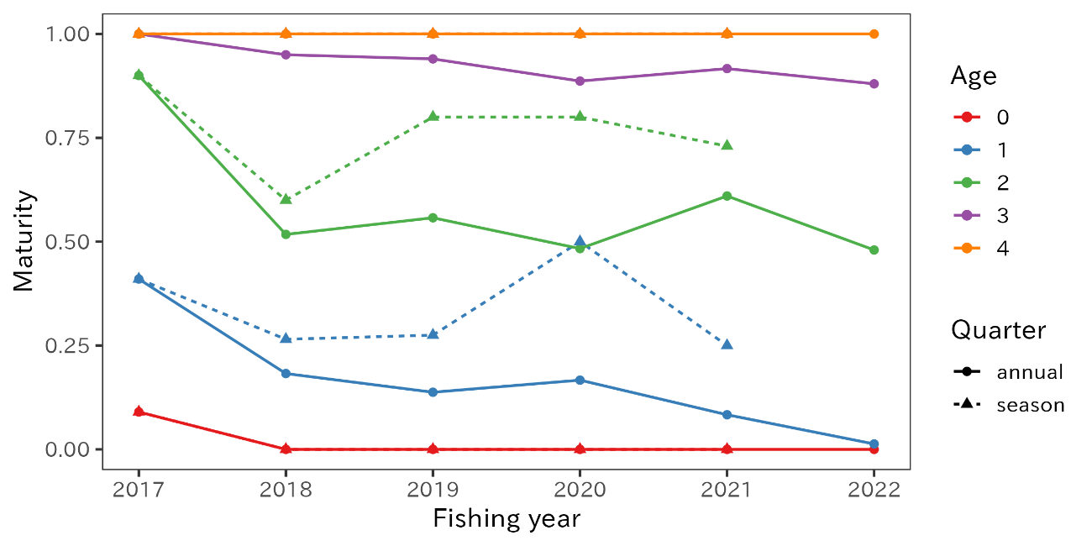
Figure 2. Maturity of chub mackerel by fishing year from Chinese catch. The maturity rates of age-4 represent age-4+ since all fish above age-4 are 100% matured.

Japan
Japanese data on maturity at age is based on Watanabe and Yatsu (2006) and Watanabe (2010) with recent maturity at age determined based on the empirical observations of the catch samples obtained by research surveys around the main spawning ground and by subsampling of the catch at major landing ports. The gonadosomatic index (GSI) and gonad index (GI) are used to determine the fish is matured if GSI is greater than 2.5 or GI is greater than 3.0 (Watanabe and Yatsu 2006, Yukami et al. 2009, Manabe et al. 2021).
Due to the spawning season is limited to Q1 and Q2 of the calendar year, Japan does not estimate a quarterly maturity at age as Q3 and Q4 are considered as the season of post-development and underdevelopment, respectively. Therefore, maturity at age by Japan is on a yearly value focused on the spawning season.
Table 3 and Figure 3 show the yearly maturity at age of chub mackerels in Japan from 1970 to 2022. The maturity rate at age fluctuates historically from early maturation (80% of age-2 are matured in the early 2000s) to late maturation (only 20% of age-2 are matured in the 1970s). Recent maturation status remains the same since 2016 where chub mackerels are fully matured at age-4 and partially (0.3 = 30%) matured at age-3 while age-2 or less are immature (Figure 3). Since 1970, maturity at age from Japanese catch present a dynamic shift. Watanabe and Yatsu (2006) and Watanabe (2010) suggest that such variability in maturity at age may be caused by the density effect as higher density (biomass) delays maturation.

Table 3. Yearly maturity at age from Japan.

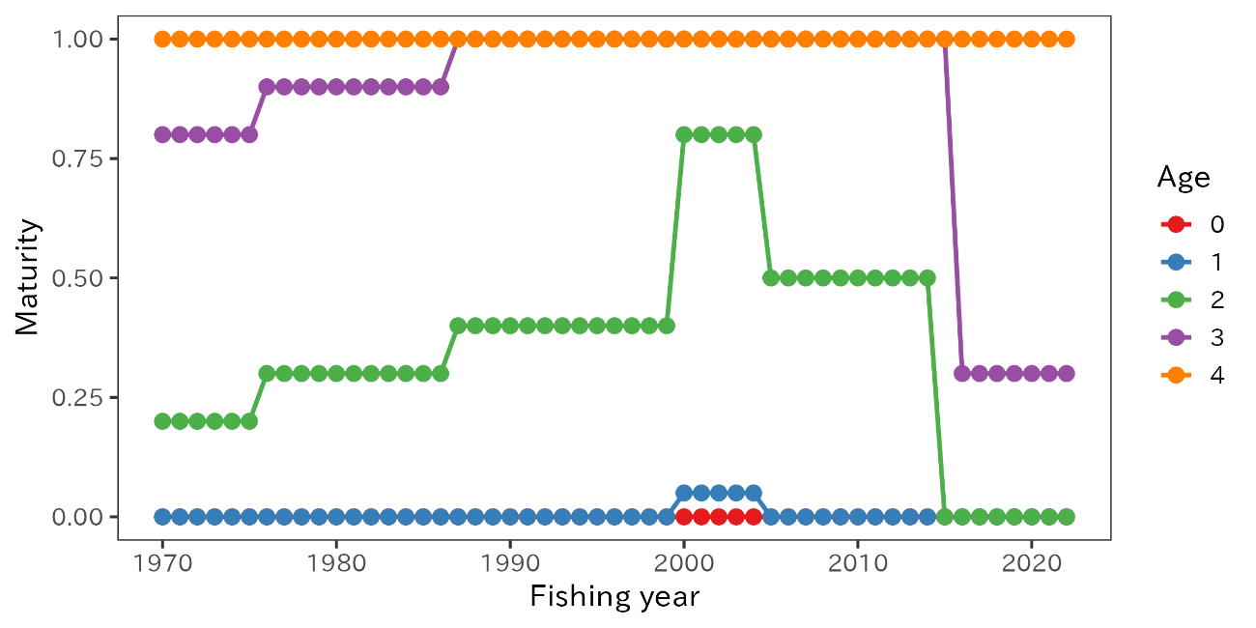
Figure 3. Maturity of chub mackerel in Japan. The maturity rates of age-4 represent age-4+ since all fish above age-4 are 100% matured.

Comparison of Chinese and Japanese maturity at age
Chinese and Japanese data are compared in Figure 4. Overall, Chinese maturity at age is higher for age 1-3 than the Japanese data. Especially for age-1, Chinese maturity at age is equivalently matured as Japanese age-3, which Chinese age-3 is mostly matured. Age-0 is fully immature and age-4+ are fully matured for both data except for age-0 in 2017 for Chinese data.
Chub mackerel is considered as capital breeder and gonadal development is estimated to begin from autumn (Yoneda et al. 2022). Chinese maturity data based on empirical observation of gonads provides insight to the development of gonad before the spawning season during the winter migration. However, in consideration with known spawning area located only within Japanese EEZ (Kanamori et al. 2019, Yukami et al. 2023), Japanese maturity at age data is expected to indicate the maturity at age of chub mackerel.
The maturity at age data for stock assessment is a key term to estimate spawning stock biomass although the exact value remains unclear according to the submitted data. Considering the availability of data, maturity at age for 1970-2016 is limited to the Japanese data. For the continuity of the data origin, Japanese maturity at age is recommended to be used as proxy values for 2017-2022. However, further study is needed to keep understanding the maturity of chub mackerels in the northwestern Pacific Ocean.

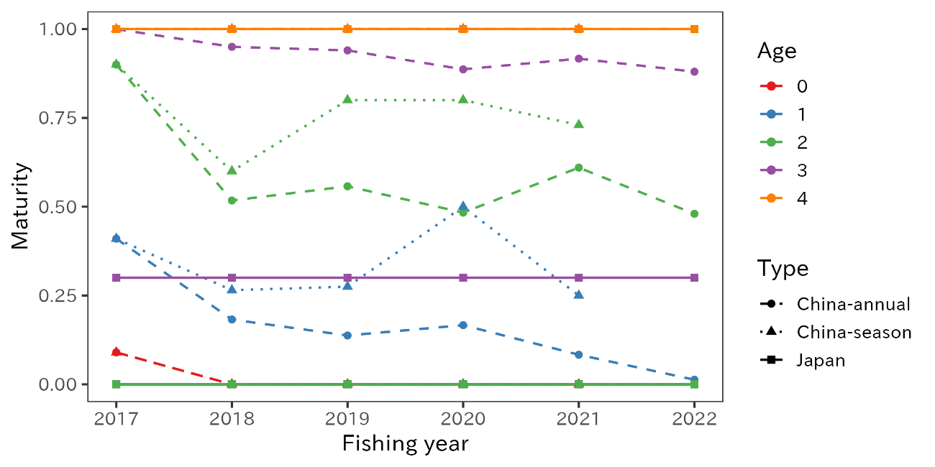
Figure 4. Comparison of annual maturity at age from Japan (solid line with square) and two Chinese data: annual mean (dashed line with circle) and seasonal mean (dotted line with triangle) from 2017 to 2022. All age-4+ fish are considered as 100% matured.

Reference

Watanabe, C., Yatsu, A. (2006). Long-term changes in maturity at age of chub mackerel (Scomber japonicus) in relation to population decline in the waters off northeastern Japan. Fish. Res., 78:2-3, 323-332. (doi: 10.1016/j.fishres.2006.01.001)
Watanabe, C., (2010). Changes in the reproductive traits of the Pacific stock of chub mackerel Scomber japonicus and their effects on the population dynamics. Bull. Jpn. Soc. Fish. Oceanogr. 74, 46-50 (in Japanese).
Manabe A., Kamimura, Y., Ichinokawa, M., Oshima, K. (2021). Maturity at age of chub mackerels under different stock level in the northwestern Pacific Ocean. NPFC-2021-TWG CMSA04-WP07.
Yukami, R., Oshimo, S., Yoda, M., and Hiyama, Y. (2009). Estimation of the spawning grounds of chub mackerel Scomber japonicus and Scomber australasicus in the East China Sea based on catch statistics and biometrics data. Fish. Sci. 75, 167-174. (doi: 10.1007/s12562-008-0015-7)
Yukami, R., Nishijima, S., S., Kamimura, Y., Furuichi, S., and Watanabe, R. (2023). Stock assessment and evaluation for the Pacific stock of chub mackerel (fiscal year 2022). (available at https://abchan.fra.go.jp/wpt/wp-content/uploads/2023/04/details_2022_05.pdf) (last accessed 2023/12/21, in Japanese)
Yoneda M., Kitano, H., Nyuji, M, Nakamura, M., Takahashi, M., Kawabata, et al. (2022). Maternal spawning experience and thermal effects on offspring viability of chub mackerel and their influence on reproductive success. Front. Mar. Sci. 9: 1063468. (doi: 10.3389/fmars.2022.1063468)

