NPFC-2018-COM04-MIP01 Rev. 2
DETAILS FOR THE 3rd TECHNICAL AND COMPLIANCE COMMITTEE; 2nd FINANCE AND ADMINISTRATION COMMITTEE; AND
4th COMMISSION MEETING
28th June – 5th July 2018
Tokyo, Japan
The 3rd Technical and Compliance Committee meeting, 2nd Finance and Administration Committee meeting and the 4th Session of the Commission will be held in Tokyo, Japan during 28th June – 5th July 2018. To facilitate your travel arrangement, the Secretariat and Organizer have prepared information for your reference as below.
- Dates
- Venue of Meetings
- Meeting Contact and Documentation
- Visa Information
- Accommodation Guide
- Airport Information and Transport to Hotels Near the Meeting Venue
- Map
- Meeting Registration
- Social Events
- Other Information

1. Dates
The meetings commence on 28th June 2018 and carry on through to 5th July 2018 as follows:
- 3rd Technical and Compliance Committee (TCC), 28th – 30th June 2018
- Head of Delegation (HOD) Meeting 1st July 2018 (1600 – 1800 hrs.)
- 2nd Finance and Administration Committee (FAC), 2nd July 2018
- 4th Annual Session of the NPFC, 3rd – 5th July 2018

2. Meeting Venue
The 3rd TCC meeting will be held at the TOKYO UNIVERSITY OF MARINE SCIENCE AND TECHNOLOGY, located at the 2nd Floor of Hakuyo Hall, 4-5-7 Konan Minato-ku, Tokyo 108-8477 Japan, in the Multipurpose Conference Room. Secretariat room shall be the NPFC Secretariat Office, 2nd floor of Hakuyo Hall. (Tel +81-80-5478-8717)
The Heads of Delegation Meeting shall be held at the 3rd Floor of Shinagawa Prince Hotel while the 2nd FAC meeting and 4th Annual Session of NPFC shall be held at the 28th Floor of the same hotel, across from the Shinagawa Railway Station on the Takanawa side.

3. Meeting Contact and Documentation

Online registration service for participants is on the NPFC website www.npfc.int.
Please log in to be able to register through the web by 14th June 2018 and retrieve your meeting documents.
4. Visa information:
An official invitation letter is essential for participants to apply for a Japanese visa. Each delegation is kindly requested to provide information in the form of Attachment 1 to the meeting coordinator, Mr. Ryotaro Okazaki (ryotaro_okazaki770@maff.go.jp), by 28th May 2018 to facilitate the invitation letters from Japan for visa purposes.

5. Accommodation
Each participant is responsible for making his or her own hotel arrangements. There are several hotels near Shinagawa station. Recommended hotels are listed in the table below:
Hotel Name | Transportation | Reservation
Shinagawa Prince Hotel | TCC: 15-minute walk to the meeting venue  FAC&COM: meeting room at 26th floor | 10-30 Takanawa 4-chome, Minato-ku Tokyo, 108-8611 Japan  http://www.princehotels.com/shinagawa/
Keikyu EX Inn Shinagawa-Ekimae | TCC: 15-minute walk to the meeting venue  FAC&COM: 5-minute walk to the meeting venue | 3-13-3 Takanawa, Minato-ku Tokyo, 108-0074  http://www.keikyu-exinn.co.jp/hotel/shinagawa/en/index.html
Keikyu EX Inn Takanawa | TCC: 15-minute walk to the meeting venue  FAC&COM: 5-minute walk to the meeting venue | 4-10-8 Takanawa, Minato-ku Tokyo, 108-0074  http://www.keikyu-exinn.co.jp/hotel/takanawa/languages/en.html
Toyoko Inn  Tokyo Shinagawa-eki Konan-guchi Tennozu | TCC: 10-minute walk to the meeting venue  FAC&COM: 15-minute walk to the meeting venue | 2-2-35, Higasi-shinagawa Shinagawa-ku, Tokyo, 140-0002  https://www.toyoko-inn.com/index.php/eng/search/detail/00244.html

6. Airport Information and Transport to the Recommended Hotels
The venue of the meetings, Tokyo University of Marine Science and Technology, is located near Shinagawa station in Tokyo. The first three recommended hotels are situated close to the station.
- From Haneda International Airport to Shinagawa Station, Tokyo (recommended airport for easy access to the meeting venue)
  - By Train
The trip takes about 15-20 minutes and costs about 500 JPY. Please travel to Shinagawa Station by Keikyu Line. The recommended hotels (Shinagawa Prince Hotel, Keikyu EX Inn Shinagawa-Ekimae and Keikyu EX Inn Takanawa) are within walking distance (1-5 min).
If you stay in Toyoko Inn Tokyo Shinagawa-eki Konan-guchi Tennozu, please take Tokyo Monorail train. The trip takes about 15 minutes and costs 340 JPY.
  - By Limousine Bus
The trip takes about 25-60 minutes and costs 720 JPY. For timetable and more information on the Limousine Bus, please visit
https://www.limousinebus.co.jp/en/bus_services/haneda/shinagawa.html

- From Narita International Airport to Shinagawa Station, Tokyo
  - By Train
The trip takes about 1 hour and costs 3,190 JPY (one-way) by Narita Express (N’EX). The N’EX round trip ticket fare is only 4,000 JPY. The recommended hotels (Shinagawa Prince Hotel, Keikyu EX Inn Shinagawa-Ekimae and Keikyu EX Inn Takanawa) are within walking distance (1-5 min). For timetable and more information, please visit: N’EX http://www.jreast.co.jp/e/nex/index.html
Alternatively, you can take Narita Sky Access. The trip takes about one and a half hours and costs about 1,520 JPY.
  - By Limousine Bus
The trip takes about 90-105 minutes and costs 3,100 JPY. For timetable and more information on the Limousine Bus, please visit
http://www.limousinebus.co.jp/en/areas/bus_stop/nrt/ebisu_shinagawa/dep/38/#anc004

7. Map
Location of the meeting venue and the recommended hotels
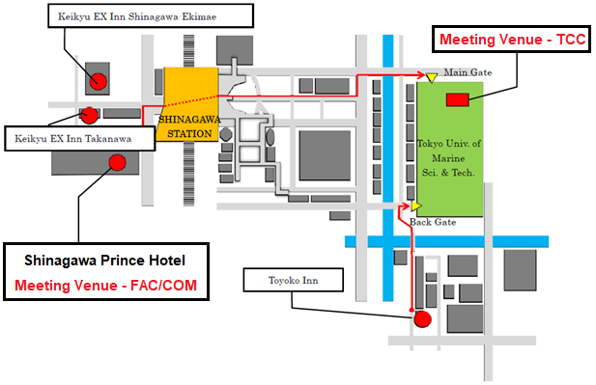

8. Meeting Registration
Participants will be able to register and pick up their information package in the following time:
- TCC meeting (28th June) – from 8:30 to 09:00 for all participants;
- FAC meeting (2nd July) – from 8:30 to 09:00;
- NPFC meeting (3rd July) – from 8:30 to 09:00.
If this registration time is not convenient for you, please ask the Secretariat staff in the Secretariat room for your registration.

9. Social Events
To be determined and announced at the meeting.

10. Other Information

WiFi
For meetings in TUMSAT:
SSID: NPFC2018
Password: 20Tokyo18
For the 4th Annual Session, the WiFi settings will be available at the Conference Room of the Shinagawa Prince Hotel.

Electricity
The voltage in Japan is 100 Volt, which is different from North America (120V), Central Europe (230V) and most other regions of the world. Japanese electrical plugs have two, non-polarized pins the fit into North American outlets, as shown below.
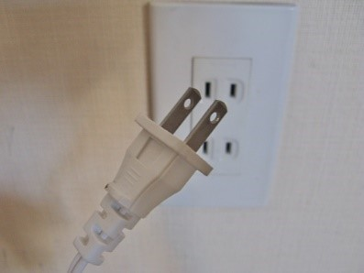
A portable plug adaptor may be necessary to use your electronic devices.

EMERGENCY INFORMATION
Police Emergency call – 110
Fire, Ambulance or Emergency Rescue Emergency call – 119

First Aid Kit available at the Secretariat

NPFC Secretariat Room
To be determined and announced
NPFC Secretariat Contacts
Secretariat (mobile phone): 090-9689-4321
Executive Secretary: 070-3606-0031

******************************************************************************

If you have any questions regarding visas, please do not hesitate to contact:
Mr. Ryotaro Okazaki
E-mail: ryotaro_okazaki770@maff.go.jp
Tel: +81-03-3591-1086

If you have any questions regarding meeting preparations, please do not hesitate to contact:
Mr. Mervin OGAWA
Tel: +81-3-5479-8717
E-mail: mogawa@npfc.int

Attachment 1 The Fisheries Agency of Japan is willing to prepare an Invitation Letter for your visa application to attend the NPFC Meetings in Tokyo, Japan.

Please provide a list which includes the following information for each participant.

EXAMPLE
First Name: Peter
Last Name: FLEWWELLING
Sex (F/M): M
Organization: North Pacific Fisheries Commission,
Title: Compliance Manager
Passport Number: YYYY
Date of Birth: August (Date), (Year)
Date of Issue: March (Date), (Year)
Date of Expiry: March (Date), (Year)
Passport Issuing Authority: Ministry of Foreign Affairs, Government of Canada
Period of Stay in JAPAN: February 2, 2016 – February 1, 2020
Place of Applying for visas: Embassy of JAPAN in Manila, Philippines
Arrival Airport: Haneda International Airport
Departure Airport: Haneda International Airport
Hotel Name: Shinagawa Prince Hotel

First Name:
Last Name:
Sex (F/M):
Organization:
Title:
Passport Number:
Date of Birth:
Date of Issue:
Date of Expiry:
Passport Issuing Authority:
Period of Stay in JAPAN:
Place of Applying for visas:
Arrival Airport:
Departure Airport:
Hotel Name:

