NPFC-2018-SC03-MIP01 (Rev. 2)

DETAILS FOR THE MEETINGS OF THE SCIENTIFIC COMMITTEE AND SMALL SCIENTIFIC COMMITTEES
9-20 April 2018
Tokyo, Japan

This is general information to assist you in your travels to the meetings. This information package includes:
- Dates
- Venue of the Meetings
- Meeting Contact Documentation
- Visa Information
- Accommodation
- Airport Information and Transport to the Recommended Hotels
- Map
- Meeting Registration
- Social Events
- Other Information

DATES:

The meetings commence on 9 April 2018 and carry on through to 20 April 2018 as follows:

3rd SSC on Vulnerable Marine Ecosystems, 9-10 April

1st SSC on Bottom Fish, 11-12 April

3rd SSC on Pacific Saury, 13, 14, 16 April

3rd Scientific Committee, 17-20 April

VENUE OF THE MEETINGS
The meetings will be held at the Tokyo University of Marine Science and Technology:
Hakuyo Hall, Tokyo University of Marine Science and Technology, Shinagawa Campus,
4-5-7 Konan, Minato-ku, Tokyo.
https://www.kaiyodai.ac.jp/english/
Conference room: Multipurpose Conference room, 2nd floor
Secretariat room: NPFC Secretariat, 2nd floor.

MEETING CONTACT DOCUMENTATION
Online registration service for participants is on the NPFC website www.npfc.int. Please log in to be able to register. The deadline for registration is April 1, 2018.

VISA INFORMATION
An official invitation letter is essential for participants to apply for a Japanese visa. Each delegation who applies for a Japanese visa is requested to provide information in the form of Attachment 1 by March 09, 2018 to Mr. Ryotaro Okazaki (ryotaro_okazaki770@maff.go.jp).

ACCOMMODATION
Each participant is responsible for making his or her own hotel arrangements. There are several hotels near Shinagawa station. Recommended hotels are listed in the table below:
Hotel Name | Transportation | Reservation
Shinagawa Prince Hotel | 15 minute walk to the meeting venue | 10-30 Takanawa 4-chome, Minato-ku Tokyo, 108-8611 Japan  http://www.princehotels.com/shinagawa/
Keikyu EX Inn Shinagawa-Ekimae | 15 minute walk to the meeting venue | 3-13-3 Takanawa, Minato-ku Tokyo, 108-0074  http://www.keikyu-exinn.co.jp/hotel/shinagawa/en/index.html
Keikyu EX Inn Takanawa | 15 minute walk to the meeting venue | 4-10-8 Takanawa, Minato-ku Tokyo, 108-0074  http://www.keikyu-exinn.co.jp/hotel/takanawa/languages/en.html
Toyoko Inn  Tokyo Shinagawa-eki Konan-guchi Tennozu | 10 minute walk to the meeting venue | 2-2-35, Higasi-shinagawa Shinagawa-ku, Tokyo, 140-0002  https://www.toyoko-inn.com/index.php/eng/search/detail/00244.html

AIRPORT INFORMATION AND TRANSPORT TO THE RECOMMENDED HOTELS
The venue of the meetings, Tokyo University of Marine Science and Technology, is located near Shinagawa station in Tokyo. The first three recommended hotels are situated close to the station.

- From Haneda International Airport to Shinagawa Station, Tokyo (recommended airport for easy access to the meeting venue)
  - By Train
The trip takes about 15-20 minutes and costs about 500 JPY. Please travel to Shinagawa Station by Keikyu Line. The recommended hotels (Shinagawa Prince Hotel, Keikyu EX Inn Shinagawa-Ekimae and Keikyu EX Inn Takanawa) are within walking distance (1-5 min).
If you stay in Toyoko Inn Tokyo Shinagawa-eki Konan-guchi Tennozu, please take Tokyo Monorail train. The trip takes about 15 minutes and costs 340 JPY.

  - By Limousine Bus
The trip takes about 25-60 minutes and costs 720 JPY. For timetable and more information on the Limousine Bus, please visit
https://www.limousinebus.co.jp/en/bus_services/haneda/shinagawa.html

  - By taxi
The trip takes about 25-50 minutes and costs about 5,000 JPY.

- From Narita International Airport to Shinagawa Station, Tokyo
  - By Train
The trip takes about 1 hour and costs about 3,000 JPY by Narita Express (N’EX). The recommended hotels (Shinagawa Prince Hotel, Keikyu EX Inn Shinagawa-Ekimae and Keikyu EX Inn Takanawa) are within walking distance (1-5 min). For timetable and more information, please visit: N’EX http://www.jreast.co.jp/e/nex/index.html
Alternatively, you can take Narita Skyaccess. The trip takes about 1 and a half hours and costs about 1,500 JPY.

  - By Limousine Bus
The trip takes about 90-105 minutes and costs 3,100 JPY. For timetable and more information on the Limousine Bus, please visit
https://www.limousinebus.co.jp/en/platform_searches/index/1/38

MAP
Location of the meeting venue, recommended hotels (●) and receptions ( )

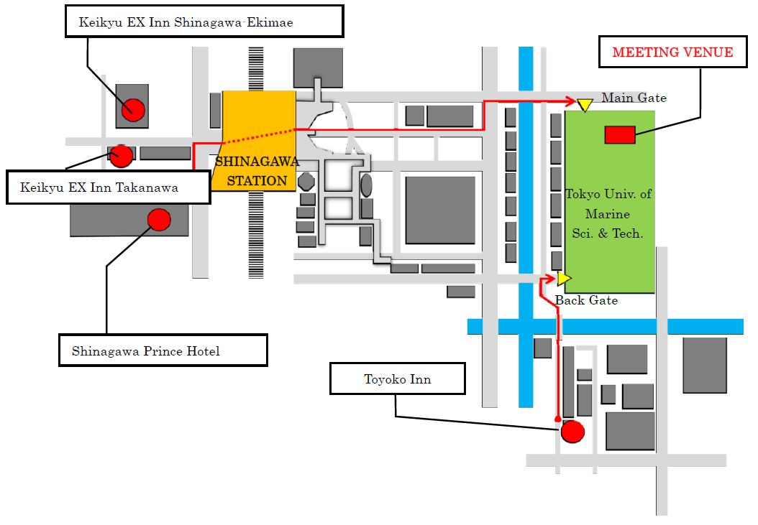
Landmark Square
Tsubame Grill
MEETING REGISTRATION
Participants will be able to register and pick up their information package from 8:30 to 9:00 on the first day of each meeting. If this registration time is not convenient for you, please ask the Secretariat staff in the meeting room for your registration.

SOCIAL EVENTS
There will be two receptions organized by the host Member and the Commission:
10 April, 6:30-9:00pm – Tsubame Grill https://goo.gl/maps/18JJsvPX1a32
17 April, 6:30-8:30pm – The Landmark Square
https://www.landmark-tokyo.com/banquet/facility.html
All meeting participants are welcome!

OTHER INFORMATION
WiFi
SSID: NPFC2018
Password: 20Tokyo18
Electricity
The voltage in Japan is 110 Volt. Japanese electrical plugs have two, non-polarized pins the fit into North American outlets, as shown on the picture. A portable plug adaptor may be necessary to use your electronic devices.

EMERGENCY INFORMATION
Police Emergency call – 110
Fire, Ambulance or Emergency call – 119
Emergency Rescue

******************************************************************************

If you have any questions regarding visas, please do not hesitate to contact:
Mr. Ryotaro Okazaki
E-mail: ryotaro_okazaki770@maff.go.jp
Tel: +81-03-3591-1086

If you have any questions regarding meeting preparations, please do not hesitate to contact:
Dr. Aleksandr Zavolokin
E-mail: azavolokin@npfc.int
Tel: +81-3-5479-8717
Attachment 1

Fisheries Agency of Japan is willing to prepare an Invitation Letter for your visa application to attend the meetings which will be held in Tokyo, JAPAN.

Please fill in the required information on the invitee as follows:

EXAMPLE

First Name: Kengo
Last Name: TANAKA
Sex (F/M): M
Organization: Fisheries Agency,
Title: Senior Fisheries Negotiator, Fisheries Agency
Passport Number: YYYY
Date of Birth: August 8, 1962
Date of Issue: March 06 2012
Date of Expiry: March 06 2022
Passport Issuing Authority: Ministry of Foreign Affairs, Japan
Period of Stay in JAPAN: January 20 – January 22, 2015
Place of Applying for visas: Embassy of JAPAN in Moscow, Russia
Arrival Airport: Narita International Airport
Departure Airport: Narita International Airport
Hotel Name: Shinagawa Prince Hotel

First Name:
Last Name:
Sex (F/M):
Organization:
Title:
Passport Number:
Date of Birth:
Date of Issue:
Date of Expiry:
Passport Issuing Authority:
Period of Stay in JAPAN:
Place of Applying for visas:
Arrival Airport:
Departure Airport:
Hotel Name:

