NPFC-2018-WS VME01-MIP01 (Rev. 1)

DETAILS FOR NPFC/FAO WORKSHOP
Protection of Vulnerable Marine Ecosystems in the North Pacific Fisheries Commission Area: applying global experiences to regional assessments
12-15 March 2018
Yokohama, Japan

This is general information to assist you in your travels to the workshop. This information package includes:
- Dates
- Venue of Workshop
- Meeting Contact Documentation
- Visa Information
- Accommodation
- Airport Information and Transport to the Recommended Hotels
- Map
- Meeting Registration
- Social Events
- Other Information

DATES: 12-15 March 2018

VENUE OF WORKSHOP
The workshop shall be held at the National Research Institute of Fisheries Science (NRIFS), Japan Fisheries Research and Education Agency in Yokohama:
2-12-4 Fukuura, Kanazawa, Yokohama, Kanagawa 236-8648 Tel: +81-45-788-7615
http://nrifs.fra.affrc.go.jp/index_e.html
Conference room: International Conference room, 3rd floor
Secretariat room: Special Meeting Room, 3rd floor

MEETING CONTACT DOCUMENTATION
Online registration service for participants is on the NPFC website www.npfc.int. Please log in to be able to register. The deadline for registration is March 4th, 2018.

VISA INFORMATION
An official invitation letter is essential for participants to apply for a Japanese visa. Each delegation who applies for a Japanese visa is requested to provide information in the form of Attachment 1 by February 12, 2018 to Mr. Ryotaro Okazaki (ryotaro_okazaki770@maff.go.jp).

ACCOMMODATION
Each participant is responsible for making his or her own hotel arrangements. There are many hotels in central Yokohama. Recommended hotels are listed in the table below:
Hotel Name | Transportation | Reservation
New Otani Inn Yokohama premium  (recommended) | A bus will be provided to transport participants from the Washington Hotel Yokohama Sakuragicho to the workshop venue. Detailed schedule will be provided at the registration desk.  OR  It takes about 40-50 min by trains: from Sakuragicho Station (hotel) to Shin-Sugita Station on the JR Keihin-Tohoku Negishi Line and from Shin-Sugita Station to Shidaiigakubu Station (NRIFS) on the Seaside Line | 12,000+ JPY yen/night  1-1-7 Sakuragi-cho, Naka-ku, Yokohama City, Kanagawa Prefecture 231-8331  http://www.newotani.co.jp/innyokohama/index.html
Washington Hotel Yokohama Sakuragicho  (recommended) |  | 10,000+ JPY/night  1-101-1, Sakuragi-cho, Naka-ku, Yokohama City, Kanagawa Pref. 231-0062  http://yokohama-s.washington-hotels.jp/
Toyoko Inn | Five-minute walk to the Washington Hotel and Sakuragicho Station.  See information above for transportation from the Washington Hotel. | Approx. 7,000 JPY/night  6-55, Honcho, Naka-ku, Yokohama City, Kanagawa Pref. 231-0005  https://www.toyoko-inn.com/eng/search/detail/00050
Yokohama Techno Tower Hotel | 4 min by train: from Sangyoshinko Center Station (hotel) to Shidaiigakubu Station (NRIFS), Seaside Line, or  17 min on foot (about 1.7 km) | 10,000+ JPY/night  1-1-1 Fukuura, Kanazawa-ku, Yokohama 236-0004  http://technotower.jp/en/index.html

AIRPORT INFORMATION AND TRANSPORT TO THE RECOMMENDED HOTELS
The venue of the workshop, National Research Institute of Fisheries Science (NRIFS), is located near Shidaiigakubu Station on the Seaside Line in Yokohama. The recommended hotels are situated close to Sakuragicho Station on the Negishi Line. A shuttle bus will be arranged to transport participants from the recommended hotels to the workshop venue.

- From Haneda International Airport to hotels in Sakuragicho, Yokohama (recommended airport for easy access to the workshop venue)
  - By Limousine Bus and Taxi
The trip takes about 40 minutes and costs 2,000-2,500 JPY. Please take the Limousine Bus bound for Yokohama City Air Terminal (YCAT). Then take a taxi to hotels in Sakuragicho area (New Otani Inn, Washington and Toyoko Inn). For timetable and more information on the Limousine Bus, please visit http://www.ycat.co.jp/en/
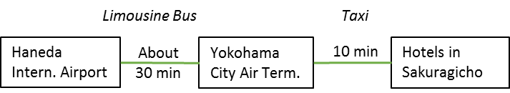

  - By Train
The trip takes about 30 minutes and costs about 600 JPY. Please travel to Yokohama Station by Keikyu Line. Then change to Negishi Line and get off at the next station, Sakuragicho. The recommended hotels (New Otani Inn, Washington and Toyoko Inn) are within walking distance (1-5 min).
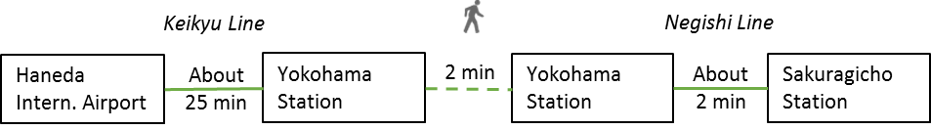

- From Narita International Airport to hotels in Sakuragicho, Yokohama
  - By Limousine Bus and Taxi
The trip takes about 2 hours and costs 5,000 – 6,000 JPY. Please take the Limousine Bus bound for Yokohama City Air Terminal (YCAT). Then take a taxi to hotels in Sakuragicho area (New Otani Inn, Washington and Toyoko Inn). For timetable and more information on the Limousine Bus, please visit http://www.ycat.co.jp/en/
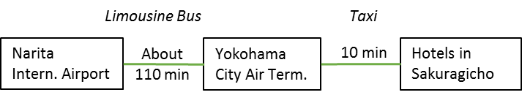

  - By Train
The trip takes about 90 minutes and costs about 4,000-4,500 JPY. Please travel to Yokohama by JR Narita Express (N’EX). Then change to Negishi Line and get off at the next station, Sakuragicho. The recommended hotels (New Otani Inn, Washington and Toyoko Inn) are within walking distance (1-5 min). For timetable and more information, please visit: N’EX http://www.jreast.co.jp/e/nex/index.html
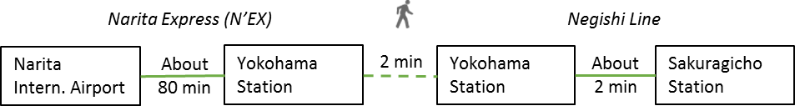

- From the recommended hotels in Sakuragicho, Yokohama to the workshop venue (NRIFS)
  - By shuttle bus
A shuttle bus will be provided to transport participants from the Washington Hotel Yokohama Sakuragicho to the workshop venue every morning at 8:45AM (departure time). The pick-up point is located near the entrance to the hotel. Please be at the pick-up point at least 10 min before departure. Detailed schedule will be provided at the registration desk.
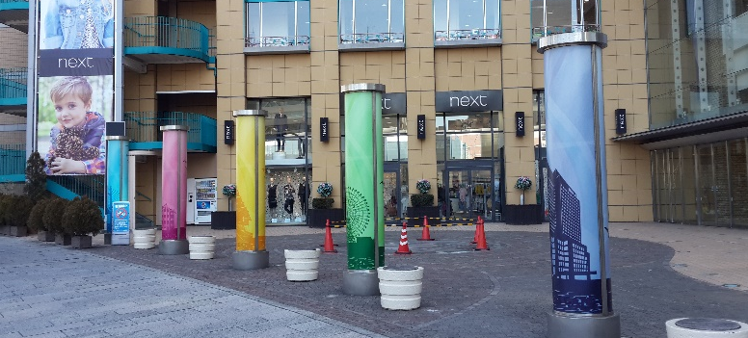
  - By taxi
The trip takes about 30 minutes and costs about 8,000-10,000 JPY.

  - By train
The trip takes about 45-50 minutes and costs about 500 JPY. Please travel to Shinsugita Station by Negishi Line. Then change to Seaside Line and get off at the Shidaiigakubu Station.
MAP

Sakuragicho area and recommended hotels
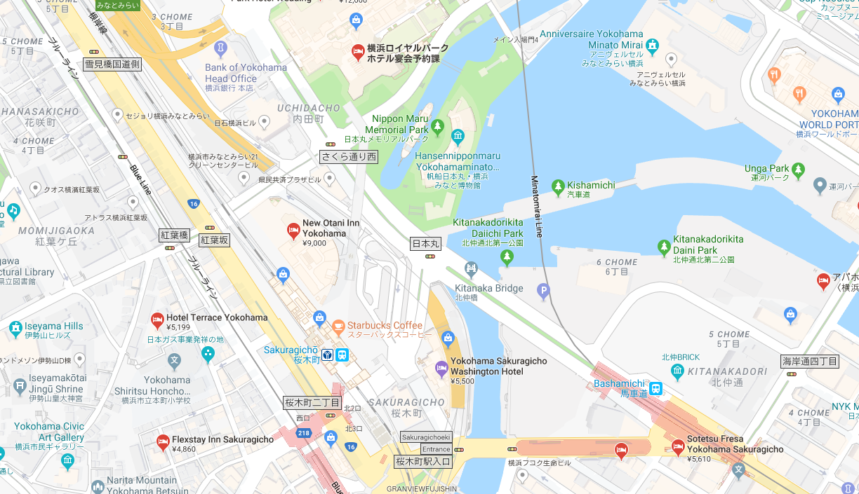
Toyoko Inn
Washington Hotel
New Otani Inn

Location of the workshop venue (NRIFS) and lunch map

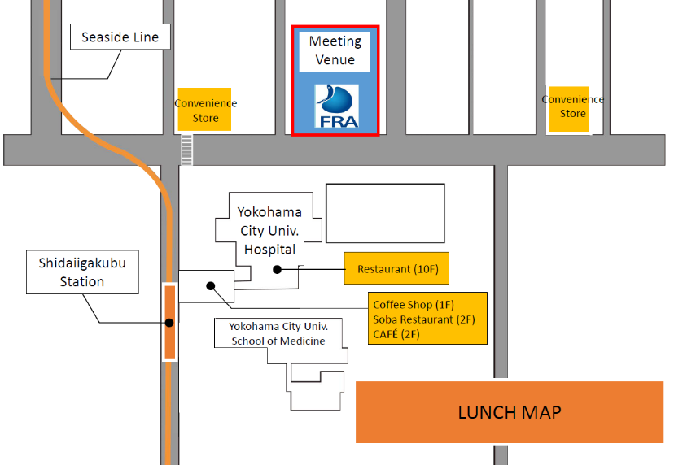

MEETING REGISTRATION
Participants will be able to register and pick up their information package from 8:30 to 9:00 on the first day of the workshop. If this registration time is not convenient for you, please ask the Secretariat staff in the meeting room for your registration.

SOCIAL EVENTS
Participants are invited to a reception which will be held in the Pier 21 Seafood Bistro located in the Pacifico Yokohama National Convention Hall of Yokohama on March 12th at 6:00-9:00pm.

OTHER INFORMATION
WiFi
SSID: NPFC2018
Password: 20Yokohama18

Electricity
The voltage in Japan is 110 Volt. Japanese electrical plugs have two, non-polarized pins the fit into North American outlets, as shown on the picture. A portable plug adaptor may be necessary to use your electronic devices.

EMERGENCY INFORMATION
Police Emergency call – 110
Fire, Ambulance or Emergency call – 119
Emergency Rescue

******************************************************************************
If you have any questions regarding visas, please do not hesitate to contact:
Mr. Ryotaro Okazaki
E-mail: ryotaro_okazaki770@maff.go.jp
Tel: +81-03-3591-1086

If you have any questions regarding meeting preparations, please do not hesitate to contact:
Dr. Aleksandr Zavolokin
E-mail: azavolokin@npfc.int
Tel: +81-3-5479-8717
Attachment 1

Fisheries Agency of Japan is willing to prepare an Invitation Letter for your visa application to attend the NPFC/FAO VME workshop which will be held in Yokohama, JAPAN.

Please fill in the required information on the invitee as follows:

EXAMPLE

First Name: Kengo
Last Name: TANAKA
Sex (F/M): M
Organization: Fisheries Agency,
Title: Senior Fisheries Negotiator, Fisheries Agency
Passport Number: YYYY
Date of Birth: August 8, 1962
Date of Issue: March 06 2012
Date of Expiry: March 06 2022
Passport Issuing Authority: Ministry of Foreign Affairs, Japan
Period of Stay in JAPAN: January 20 – January 22, 2015
Place of Applying for visas: Embassy of JAPAN in Moscow, Russia
Arrival Airport: Narita International Airport
Departure Airport: Narita International Airport
Hotel Name: Shinagawa Prince Hotel

First Name:
Last Name:
Sex (F/M):
Organization:
Title:
Passport Number:
Date of Birth:
Date of Issue:
Date of Expiry:
Passport Issuing Authority:
Period of Stay in JAPAN:
Place of Applying for visas:
Arrival Airport:
Departure Airport:
Hotel Name:

